1. **FIR Filter Design Overview**

A Finite Impulse Response (FIR) filter has an output defined by a weighted sum of current and past input samples:

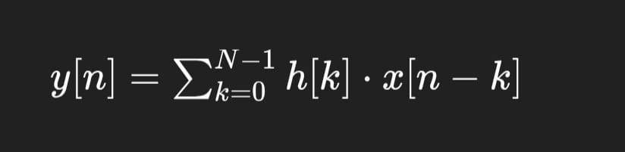

**Where:**

* h[k]h[k]h[k] are the filter coefficients (impulse response),
* x[n−k]x[n-k]x[n−k] are the input samples,
* NNN is the number of taps.

1. **Verilog Code (FIR Filter)**

module fir_filter (

input clk,

input rst,

input signed [7:0] x_in,

output reg signed [15:0] y_out

);

reg signed [7:0] shift_reg [0:3];

wire signed [15:0] mul [0:3];

wire signed [15:0] sum;

**// Coefficients scaled by 2^8 = 256 for fixed-point (0.25 * 256 = 64)**

parameter signed [7:0] h [0:3] = {64, 64, 64, 64};

**// Shift Register**

always @(posedge clk or posedge rst) begin

if (rst) begin

shift_reg[0] <= 0;

shift_reg[1] <= 0;

shift_reg[2] <= 0;

shift_reg[3] <= 0;

end else begin

shift_reg[3] <= shift_reg[2];

shift_reg[2] <= shift_reg[1];

shift_reg[1] <= shift_reg[0];

shift_reg[0] <= x_in;

end

end

assign mul[0] = shift_reg[0] * h[0];

assign mul[1] = shift_reg[1] * h[1];

assign mul[2] = shift_reg[2] * h[2];

assign mul[3] = shift_reg[3] * h[3];

assign sum = mul[0] + mul[1] + mul[2] + mul[3];

**// Output with bit shift to adjust scaling**

always @(posedge clk or posedge rst) begin

if (rst)

y_out <= 0;

else

y_out <= sum >>> 8**; // scale down result**

end

endmodule

1. **Testbench (Verilog)**

module tb_fir_filter;

reg clk, rst;

reg signed [7:0] x_in;

wire signed [15:0] y_out;

fir_filter uut (

.clk(clk),

.rst(rst),

.x_in(x_in),

.y_out(y_out)

);

always #5 clk = ~clk**; // Clock generation**

initial begin

$monitor("Time = %0d, Input = %d, Output = %d", $time, x_in, y_out);

clk = 0;

rst = 1;

x_in = 0;

#10 rst = 0;

**// Apply test inputs**

x_in = 10; #10;

x_in = 20; #10;

x_in = 30; #10;

x_in = 40; #10;

x_in = 50; #10;

x_in = 60; #10;

x_in = 70; #10;

x_in = 80; #10;

#50 $finish;

end

endmodule

**4. Simulation Results**

* Look for waveform outputs (e.g., x_in vs y_out) to verify filtering effect
* You should see the output representing a smoothed version of the input signal

**5. Performance Analysis**

Key performance metrics:

* **Latency**: 4 clock cycles (for 4-tap filter)
* **Throughput**: 1 sample per clock (after pipeline filled)
* **Resource Usage**:
  + 4 multipliers (can be optimized using MAC units)
  + 4 adders
  + Shift register for past inputs